|  |  |
| --- | --- |
| tpaa logo.bmp | Technical Note 14 |
| 1604 explained |

1. 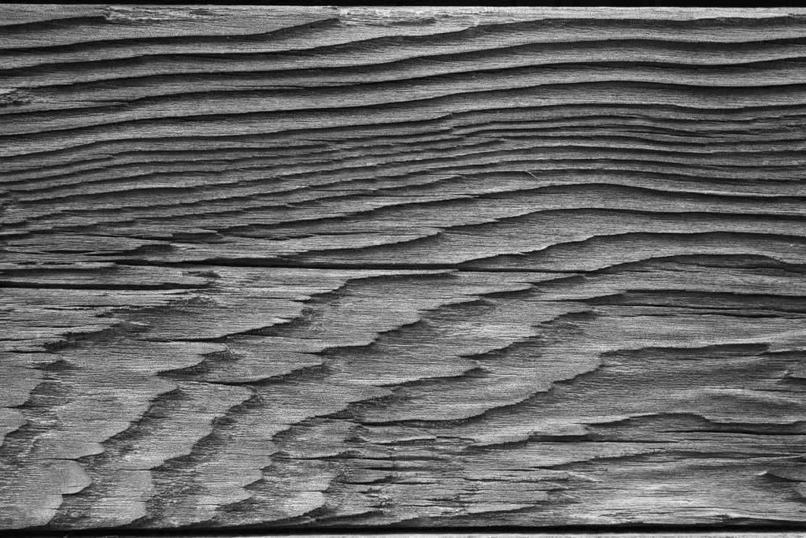

# Introduction

Australian and New Zealand Standard AS/NZS 1604 is a wood preservation standard and is made up of three parts:

* Products and treatment (Part 1),
* Verification requirements (Part 2) and
* Test methods (Part 3)

The purpose of this Technical Note is to provide the reader with a broad description of what the Standard contains and how it’s specifications are applied. Technical Notes on the Timber Preservers’ Association of Australia (TPAA) web site provide more detail of various aspects of this note and are freely available under the Publication tab of TPAA.com.au.

# Products and Treatments (Part 1)

It is important to note that despite the word ‘Treatments’ in the title, the specifications of Part 1 are ‘result’ rather than ‘process’ specifications. Part one specifies what must be present in the wood intended for different exposures, rather than how the product is to be preserved.

It is also important to note that the Standard only addresses protection against biological hazards such as borers, termites, decay or rot and marine organisms. The Standard does not set specifications for protection against physical hazards such as fire, UV breakdown or chemicals.

Part 1 of the Standard applies to all preserved products e.g. sawn timber, laminated veneer products, glue-laminated timber and reconstituted panel products.

## Durability Classification

The durability of a species is the natural ability of the heartwood (TPAA-TN3) to resist attack by insects and decay. Intuitively we know that if we put a piece of pine and a piece of spotted gum in the ground at the same time, the pine will decay or rot before the spotted gum. Pine is ‘less durable’ than spotted gum. Note that sapwood (TPAA-TN3) is deemed to be non-durable. More detail on natural durability can be found in TPAA-TN5.

Australian Standard AS5604 lists the natural heartwood durability of Australian and the most common imported timber species. Consideration of a species’ durability is important, because preservation specifications are linked to natural (heartwood) durability.

## Hazard Classes

Any use of wood is exposed to one of six biological hazards which are defined in the Standard as Hazard Classes. Each Hazard Class is prefixed by the letter ‘H’ and is given a Hazard Class number. H1 describes a borer only hazard, H2 is for termites, H3 for moderate decay, H4 severe decay, H5 very severe decay and H6 is for marine borer hazards. H1 and H2 apply when the wood is fully protected from the weather and wetting (inside a building), H3 applies to exposures that can get wet but can also dry out (outside above ground), H4 and H5 apply in ground contact applications and H6 is used for marine situations.

Apart from in the Standard itself, there is a detailed description of Hazard Classes in TPAA-TN2.

As well as defining Hazard Classes, the Standard sets preservative type, penetration and concentration for each Hazard Class.

* The preservative type is the chemicals (active ingredients) that make up the preservative. e.g. Alkaline copper quaternary (ACQ), copper azole (CuAz) etc. The Standard sets specifications for 15 different active ingredients and in some cases these ingredients may be combined.  
    
  Only copper chrome arsenate (CCA) preservative has specifications for all six hazard classes. Some preservatives may be used for only one hazard class. (TPAA-TN7)
* Preservative penetration specifications set what parts of the timber must be penetrated for a given preservative type, product, natural heartwood durability and Hazard Class.
* Preservative concentration specifications set the minimum amount of preservative that must be present in a specified zone in the wood. In the preservation industry, preservative concentration is also called preservative retention.

As the biological hazard increases (H1 to H6), the preservative penetration and concentration levels also increase.

## Marking/branding

Part 1 of the Standard, specifies the marking or branding requirements for any preservative treated product that **claims** to comply with the Standard. There must be at least three pieces of information contained in the brand:

* A unique plant identifier. This is usually a number that identifies the treatment plant where the preservative treatment was actually carried out. A company name is also a ‘unique identifier.’ TPAA maintains a list of treatment plant numbers. The plant identifier is important for chain of custody purposes.
* A preservative code number. Preservative code numbers are listed in the Standard and TPAA-TN13 Each code number identifies the preservative used to treat the wood. The preservative code number is important because it advises a chemist testing for compliance, what to analyse for and so minimises testing costs.
* A hazard class. These are any one of H1 to H6 (TPAA-TN2) **This is the main piece of information for users** because it advises where the preserved product can be reliably used.

Treatment brands may be applied as burn brands, plastic tags or ink brands. Each individual piece of preserved wood must be branded except for battens, fence palings, droppers, timber 1500 mm2 and less in cross section and timber less than 15 mm thick. These products must be pack branded. A Certificate of Treatment may be supplied by the treater, but this Certificate does not replace the brand. If the timber is not branded, it does NOT comply with the Standard.

# Testing and monitoring (Part 2)

Part 2 is intended for use by producers and importers of preserved wood. It sets out the minimum requirements needed to verify (confirm) that the preserved product meets the specifications of Part 1 of the Standard. Verification of a batch of preserved product can be achieved by using one of the options set out in Part 2.

# Test methods (Part 3)

Part 3 is for use by the testing laboratory and contains details for (amongst others):

* Determining the extent of sapwood and heartwood,
* Wood preservative solution analysis,
* Colourimetric preservative penetration tests and
* Preservative concentration (retention) analysis.

The concentration values specified in the Standard were all determined using one of the analysis methods described in Part 3. Alternative analysis techniques may be used, but the relationship to the method specified in the Standard must be determined and applied to the alternate test method.

# ---000---