Code of Practice 2
Guideline for the collection of samples for preservative compliance testing

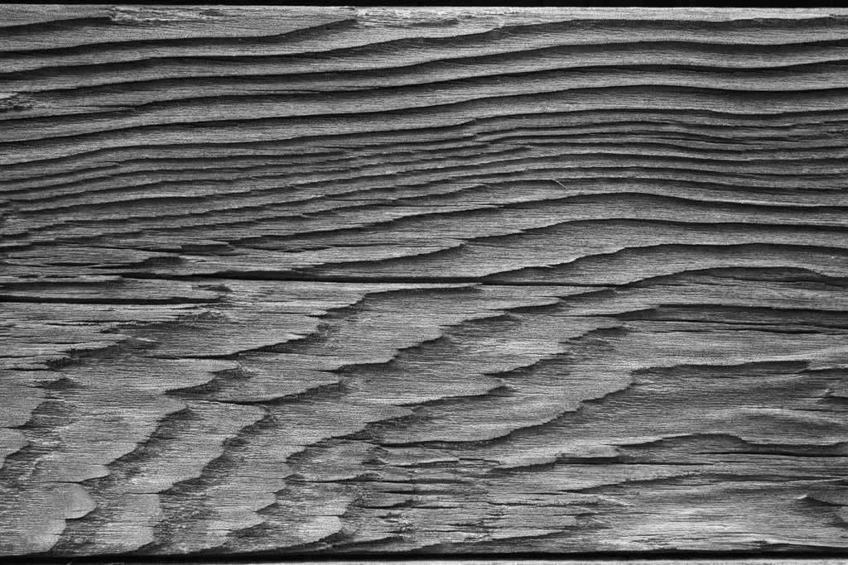

Introduction
The specifications in Australian and New Zealand standard AS/NZS1604.2:2021 Preservative-treated wood-based products Part 2 Verification requirements, must be used to able to claim compliance with Part 1 (Products and treatment) of the Standard.
The verification requirements provide informative (could do) Guidance on sampling (Appendix F) and normative (must do) Sampling and preparation of test specimens (Appendix H). The purpose of this Code of Practice is to provide the timber preservation operation with more detail on the collection of material for testing.
Collection of Timber Samples:
Timber samples should be representative of the charge and conform to the following:
- Be taken a minimum of 450 mm from end of board.
- Be the complete cross section
- A minimum length of 200 mm.
- A matching 100 mm long ‘B’ sample retained on-site.
- Be clear sound wood not nearer than 150mm from a knot and clear of defect.
- If sample is hardwood, contain more than 20% sapwood.
- If adding sacrificial sample boards to charge,
  - They should be a minimum of 1,800 mm long and
  - Be a minimum of 200 (+100) mm removed midway along the length.
Number of Samples per Charge:
- To claim compliance with the Standard, the number of samples must comply with the Verification (Part 2) of the Standard
- To monitor the process, 3 samples per charge.
Information to accompany samples submitted for testing
- Company name and address
- The preservation plant number.
- A unique identifier for the sample(s) usually Charge and replicate number e.g. Chg 1234/3
- Site contact details
- Treatment type and Hazard level
- Any other information required from the laboratory.
Chain of Custody/Record Keeping:
Once samples are collected from a charge, they are to be:
- Labelled with preservation plant number
- The unique identifier used on each sample
- The date of preservation
- The matching ‘B’ sample is to be labelled as above and stored on site for at least 6 years years
- A spreadsheet is to be completed with at least the following information:
  - The unique sample identifier
  - Date of preservation
  - Relevant charge information
    - Solution strength
    - Preservation cycle applied
    - Target absorption/uptake
    - Achieved absorption/uptake
    - Name of test laboratory
    - Date submitted to the testing laboratory
    - Test/analysis results once returned from the testing laboratory.
- Timbers samples are to be sent to – Insert list of treatment testing Laboratory names here
--- End of COP 2 ---

